Project 3: Addressing the Gender Gap in Wikipedia
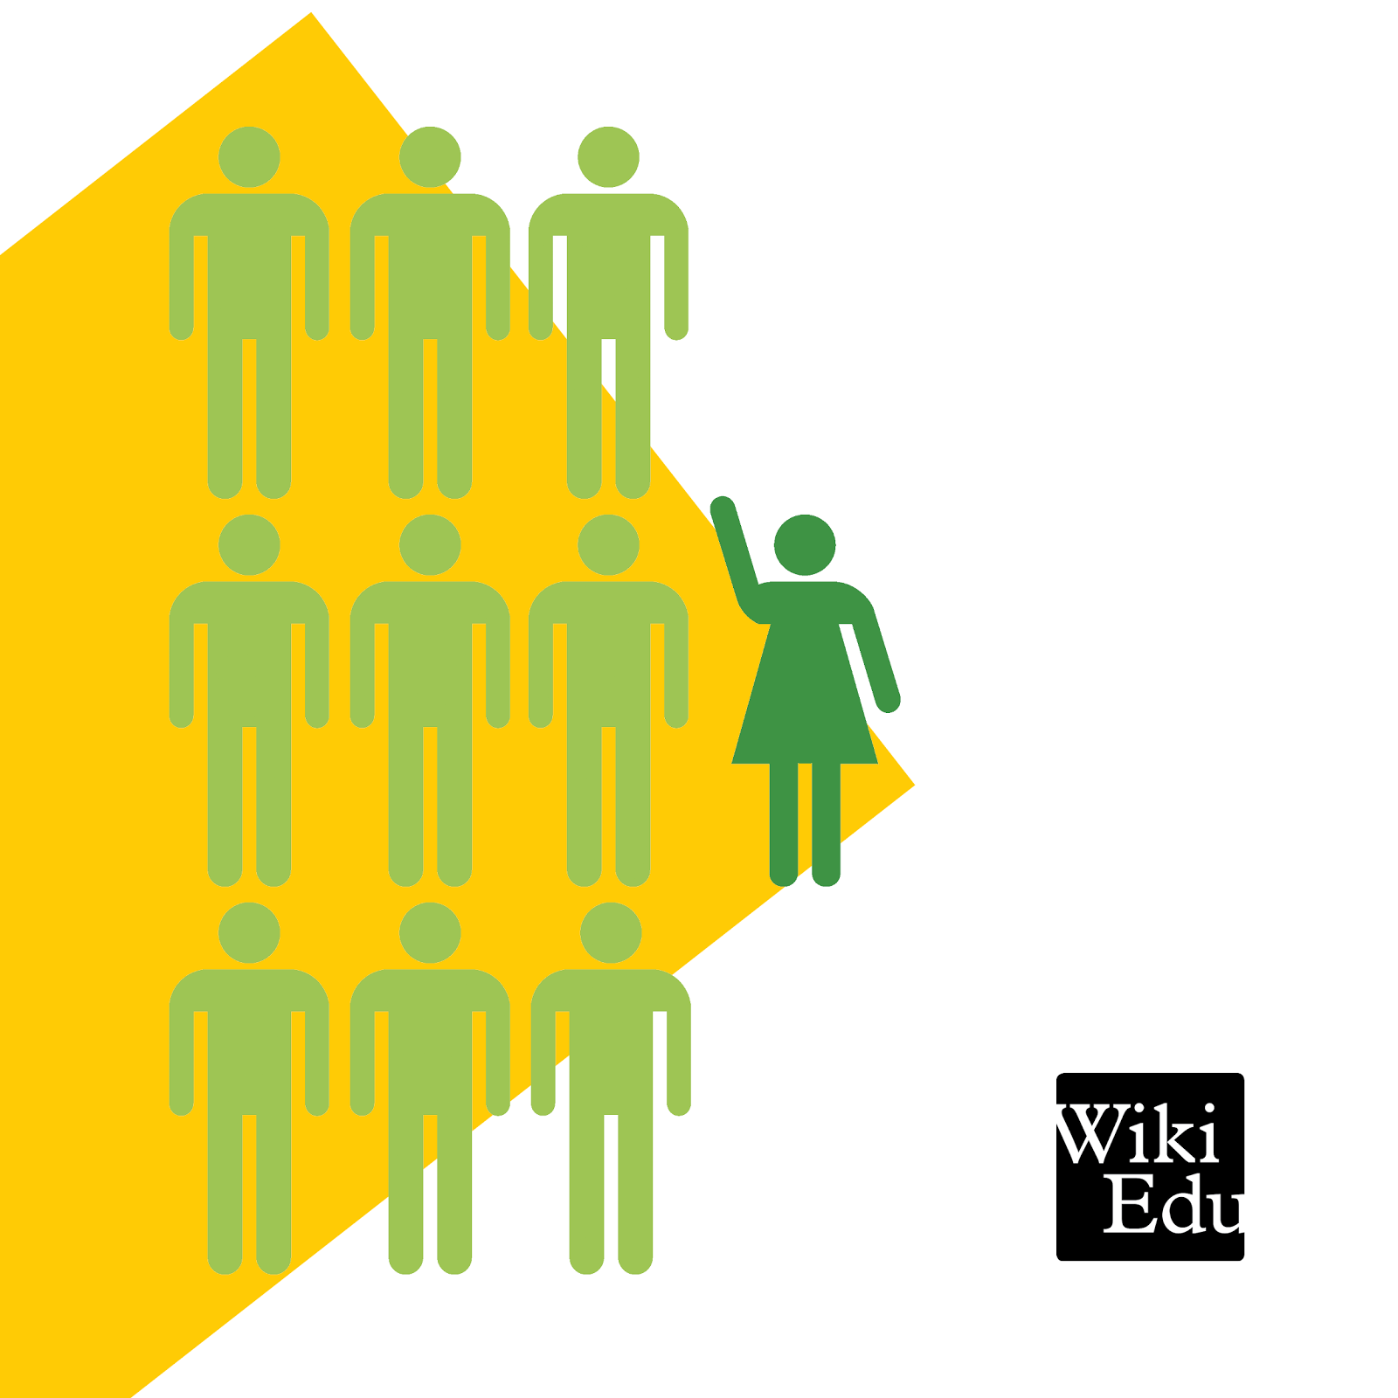
Overview: Wikipedia prides itself on its open access ethos- “the free encyclopedia anyone can edit.” But how does this philosophy break down under closer inspection? In this project, we will adress the encylopedia’s gender gap—its lack of non-male identified editors—and the problems of representation that emerge because of such homogenous editorship. I’m interested in both exploring how and why the gender gap manifests and in working to improve ommissions in representation by asking you to become a Wikipedia editor.
In other words, you’re going to contribute to Wikipedia by performing research on a topic related to gender, women’s studies, women’s representation, or lgbtq issues, identifying a need for a new article or edits to an existing article, and then contributing content to Wikipedia based on your research. In addition to our emphasis on gender and sexuality (on women writing in digital spaces) in this unit, we will also be paying close attention to what we can learn about writing and research by partcipating in an authentic (and incrediblty productive) writing community.

Disclaimer: This project is almost definitely different from other writing assignments you’ve worked on in the past. We’re going to be doing public writing in a globally accessible website. This is both terrifying and exciting: terrifying because we’re not sure how others will respond to your work, but exciting because you’ll be doing REAL writing work that will help to make Wikipedia a resource that better represents gender diversity. Remember that you have people that are supportive of your efforts: the Wikipedia Education program (who organized the Training Modules and who will read and offer feedback on your work); the instructor (myself) who will support your work and help you throughout the project; and each other, your peers in the classroom.

Give it your best, and let’s see what we can learn from this!

Components
As the major project of the course, we’re going to spend more time on your Wikipedia articles and allow for more process (in and out of class) to make sure you’re successful. This process will also include numerous steps where you produce the following documents and revisions:
- A Proposal for the Instructor in which you discuss a specific article you’ve targeted for development, why you’ve chosen that article, and what “gaps” you’ve found: article omissions that require revision or further development. 300 words. Due for in class workshop 3/26.
- An Annotated Bibliography that includes bibliographic information for each of your sources as well as quotes, summary, and paraphrase from those sources that you plan to use in your article. 400-600 words. Due by end of class period 4/2.
- A draft of your revised and developed article for peer review (published in your Sandbox). You will also send a message to your Ambassador to review this draft. 1200-1500 words (new contributions).
- A final article draft with revisions based on your peer’s and ambassador’s feedback (Wikipedia mainspace). 1200-1500 words (new contributions).
Process Milestones
- Create Wikipedia Accounts
- Complete Training Modules 1 and 2
- Explore Wikiprojects (looking for articles to edit)
- Complete Training Modules 4 and 5
- Set up User page and Sandbox- practice editing
- Finish proposals
- Workshop proposals
- Research
- Work on Annotated Bibliographies
- Workshop/share Annotated Biblipographies
- Begin drafting article edits in Sandboxes
- Finish Sandbox Drafts
- Post a link to Wiki Edu Ambassador for feedback on Sandbox draft
- Article Peer Review
- Revise according to feedback
- Publish to mainspace
- Celebrate

Source Requirements
Writing in Wikipedia, as you will learn in the Training modules, requires careful consideration of sources. Avoid plagiarism by always using in-text citations for quotes, paraphrase, and summary. Never copy/paste directly from a source. Never rely too much on quotes. Sources should be from reputable publishers (established and notable news outlets, published books, scholarly articles, etc.) Your final article should include at least 5 outside sources, more if necessary.
Length Requirements
Meeting a specific length requirement in Wikipedia is more difficult than in a traditional “paper” for a class because the encyclopedia strives for conciseness and brevity. Accordingly, if you do not anticipate that a given article is going to offer enough opportunities to meet the length requirement of 1200-1500 words (but you would still really like to work on it), you can opt to contribute edits to 2 or even 3 articles.
Project Criteria
Edits to your Wikipedia article should demonstrate an understanding of (and follow) the following Wikipedia writing conventions:
Articles use a consistently neutral style.
Articles are written as clearly and concisely as possible. Be plain, direct, unambiguous, and specific.
Articles should avoid redundancy and maintain scope. Do not bring in content that should be covered in other articles.
Articles should demonstrate careful and thorough research and source use.
Sources should be secondary, from reputable publishers (academic research, notable news and media outlets, etc.).
Sources should be carefully documented using Wikipedia conventions for References.
Quotes, summary, and paraphrase should be documented according to Wikipedia conventions (in-text citations).
Articles should contain no original research. Do not include your own opinions or interpretations of the topic.
Articles should be organized in a way that is consistent with the genre of the Wikipedia article, using heading and subheadings and sidebars if needed.
Articles should follow the basic article structure common to Wikipedia: lead, body, appendices (references, external links).
Article edits should meet the required length (1200-1500 words of original contributions or revisions).

Important Dates
3/12: In class: Assign Project. Homework: Create WP account, Complete Training Modules 1 and 2.
3/17: In class: Explore Wikiprojects.
3/19: In class: Introduce Proposal Assignment; Continue Exploring Wikiprojects; Homework: Complete Training Modules 4 and 5.
3/24: In class: Review Modules 4 and 5; Practice editing in Talk pages and mainspace. Homework: Finish Proposals.
3/26: In class: Workshop Proposals in Groups.
3/31: Introduce Database and Internet Research. Homework: Research for WP Edit. Work on Annotated Bibliography.
4/2: In class: Research; Groups share and review sources; Annotated Bibliographies due by end of class period.
4/7: In class: Review Editing Basics; Drafting Article Edits in Sandboxes. Homework: Finish Sandbox Drafts.
4/9: In ClassPost a link for Ambassador to Review Sandbox drafts. Homework: Edit/Revise References Section of Articles.
4/14: In class: Peer Review for Article Edits.
4/23: Revise articles according to ambassador’s feedback. Publish Wikipedia edits by moving content to mainspace.

Additional Resources
Wikipedia Policies and Guidelines: https://en.wikipedia.org/wiki/Wikipedia:Policies_and_guidelines
Wikipedia Education Resources: https://en.wikipedia.org/wiki/Wikipedia:Training/For_students/Resources
Chat and Help boards can be linked to from the Course Page: https://en.wikipedia.org/wiki/Education_Program:Ohio_University/Women_and_Writing_(Spring_2015)

