Created by Katie Flynn and Asher Erickson

***
Body Positivity is often classified as a concept only for women. Many people are unaware that body positivity is for everyone and doesn’t only focus on loving your body. Body Positivity promotes being healthy physically, mentally and emotionally as well. This media toolkit contains the contents for creating bathroom newsletters focusing on different aspects of body positivity, as well as a social media campaign to promote body positivity among the students of the University of Wisconsin Oshkosh.

In this toolkit you will find:
- Calendar of Newsletters
- Shareable Social Media Content
- Newsletter Examples and Templates

Calendar of Newsletters

A monthly breakdown of the themes for the Stall-Street Journal newsletters.

Month | Theme | Details
January | Body Positive Resolutions | Introduces #UWOBodyLove hashtag; Gives tips on creating body positive resolutions.
February | Eating Disorder Awareness Month | Includes various healthy dialogues regarding how to talk to someone who you may be concerned has an eating disorder. Also includes national eating disorder hotline.
March | Spring Break/ Body Shaming | Comparing your body to others’ (could be general or spring break themed): how to address differences in a healthy and body positive way.
April | Healthy at Every Size | Tips on taking care of your body that doesn't necessarily mean losing or gaining weight: drinking plenty of water, making sure to get up and move at least once every day, getting plenty of nutrients from the food you are eating. Focus on showing a diverse group of bodies in “healthy” imagery.
May | Stress/ mental health | Lists different sources of stress, then tips on how to manage it.
September | Safe drinking and/or safe sex | Back to school: staying safe and healthy.
October | Domestic Abuse Awareness Month/ mental health | Provides advice on recognizing unhealthy relationships.
November | Healthy Eating around the Holidays | Provide different tips on how to manage food related stress, and stay healthy this holiday season.
December | Stress | Provides tips on how to be healthy during a stressful time

The newsletters follow a theme that is present within that month. The content for spring semester will be laid out in the media toolkit, which will give the tools for adapting and creating the fall semester newsletters.

Newsletter Content

January
The January newsletter is an introduction newsletter, welcoming students back to campus after the break. The newsletter will contain upcoming events in January (the specific events are TBA), a welcome back message to the students, and some tips on how to create body positive New Year’s Resolutions which introduces the #UWOBodyLove hashtag.
Source:
- Article: https://www.popsugar.com/fitness/Body-Positive-New-Year-Resolutions-42848762

February
February is Eating Disorder Awareness month. This newsletter is split into two newsletters: Information about Eating Disorder Awareness month, and how to talk to someone about eating disorders. The newsletters include tips on how to start a conversation with someone that you may think has an eating disorder, and/ or disordered eating. Because of the seriousness of the newsletters, each newsletter also contains fun facts not related to eating disorders. Both newsletters provide information about the National Eating Disorder Hotline.
Sources:
- Article: https://www.nationaleatingdisorders.org/learn/help/caregivers/talk
- Facts about males with eating disorders: https://www.eatingdisorderhope.com/information/eating-disorder/male-eating-disorders-a-snapshot-of-statistics-and-their-implications
- Facts about eating disorders: http://www.anad.org/get-information/about-eating-disorders/eating-disorders-statistics/ http://www.medainc.org/httpwww-medainc-orglearn-moreabout-eating-disorders/about-eating-disorders/
- Information about the National Eating Disorder Association: https://www.nationaleatingdisorders.org/
- Birth Control Facts https://www.factretriever.com/birth-control-facts

Newsletter Content Continued

March
The March newsletter will focus on body shaming, specifically during many spring break vacations and the upcoming summer. It will give examples of body shaming and provide ways to stop the shaming and redirect the conversation in a positive way. It can also include tips on staying positive and confident in summer attire.
Sources:
- Article: Staying body positive while swimsuit shopping http://lifebru.com/easy-steps-to-stay-body-positive-while-swimsuit-shopping/ note: article is directed towards women but the concepts of dressing for the activity you are doing, staying confident, and focusing on all the fun times to come can be applied to everyone
- Article: Things you can say when you hear body shaming and negative talk: https://www.today.com/health/when-friend-says-i-m-so-fat-5-ways-stop-t60181
- Article: What is body shaming and how can we stop it https://www.waldeneatingdisorders.com/body-shaming-what-is-it-why-do-we-do-it/
- Article: how body shaming affects men https://www.consumerhealthdigest.com/mens-health/body-shaming-on-men.html

April
April will focus on maintaining healthy habits regardless of size, and explain why size doesn’t necessarily indicate health or wellness. It will also include general health tips (none of which will have anything to do with weight gain/loss or size), such as a reminder to stay hydrated, and get enough nutrients in the day.
Sources:
- Healthy at Every Size Website: https://haescommunity.com/
- Article: https://www.nationaleatingdisorders.org/what-health-every-size

Newsletter Content Continued

May
The focus of May’s newsletter will be on stress, being that it is time for finals. It will include insights on how stress affects the body and physical health, as well as methods for managing stress during exams and any other stressful situation.
Sources:
- Article: How stress affects the body https://www.mayoclinic.org/healthy-lifestyle/stress-management/in-depth/stress-symptoms/art-20050987
- Article: 10 ways to reduce stress https://www.everydayhealth.com/college-health/college-life-10-ways-to-reduce-stress.aspx

Social Media
The social media posts will share content that is featured on the Stall Street Journal newsletters. Hashtags to use: #UWOBodyLove,
January
- What are some of your body positive resolutions this year? #UWOBodyLove
- How are you going to be more body positive in 2018? #UWOBodyLove
- What are you looking forward to this semester?
February
- Show your support during Eating Disorder Awareness week! Wear purple this week for Eating Disorder Awareness and feel free to share your stories and outfits using #UWOBodyLove
- If you or anyone you know may have an eating disorder, call the National Eating Disorder Hotline at 1-800-931-2237 or there is a 24/7 crisis line. Text “NEDA” to 741741.
March
- Share something that you love about yourself! #UWOisBodyPositive
- Tell us how you’re going to be body positive during Spring Break! #UWOisBodyPositive
- Tell us your Spring Break plans!

April
- Selfie share! Tell us why you feel great about yourself today! #HealthyAtEverySize #UWOBodyLove
- Selfie Share! Share a picture of an outfit that you love! #HealthyAtEverySize #UWOBodyLove
- Tell us some of your healthy habits? #UWOBodyLove #HealthyAtEverySize
May
- What are your favorite ways to manage stress? #UWOBodyLove
- How are you managing your stress during finals? #UWOBodyLove
- Don’t forget to take care of yourself during finals! #UWOBodyLove

Sharable Content
January
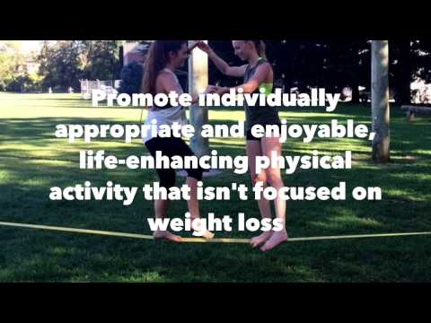
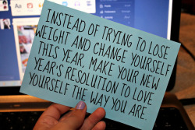

February
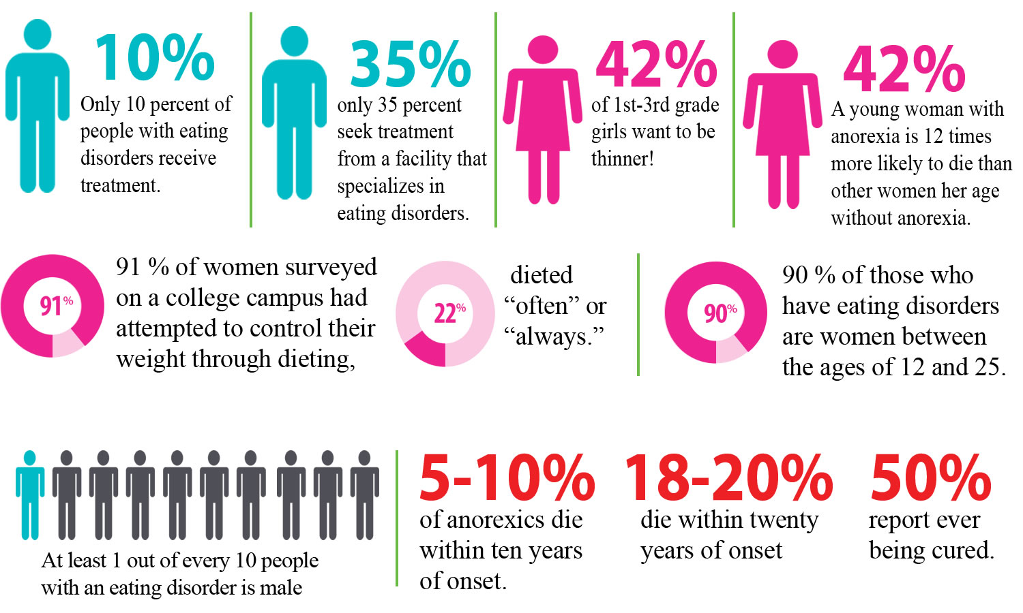

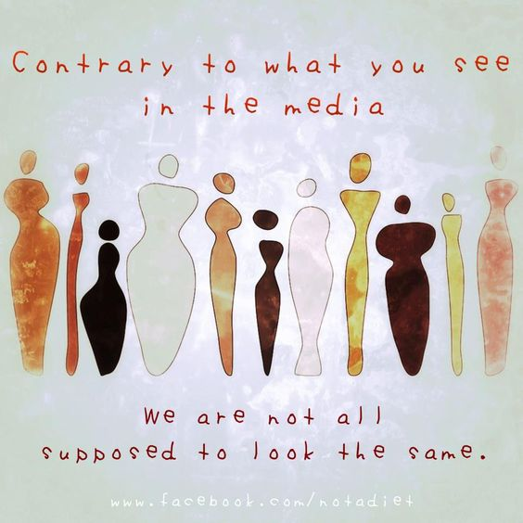
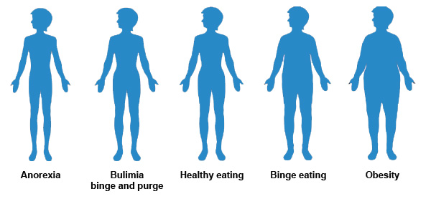
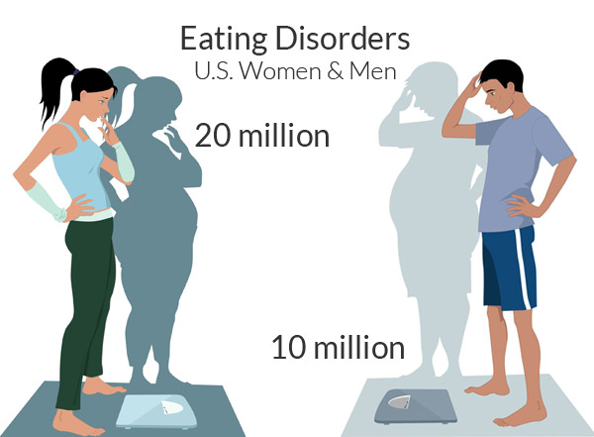

March
Target’s new swimsuit campaign

April

